Name of Student: Akshit Kumar | PRN: 25070122270
Semester: III | Year : AY 2026-27
Subject: Programming with Java
ASSIGNMENT No : 7
TITLE : Inheritance and Interfaces
Problem Statement
Implement a Java program to demonstrate inheritance and interfaces using suitable real-world examples.
Learning Objectives
To implement inheritance and interfaces for achieving code reusability and abstraction.

Programme
- Create a Shape application where Circle and Rectangle inherit from Shape and calculate area.
class Shape {
void calculateArea() {
System.out.println("Area of Shape");
}
}
class Circle extends Shape {
double radius;
Circle(double radius) {
this.radius = radius;
}
void calculateArea() {
double area = Math.PI * radius * radius;
System.out.println("Area of Circle = " + area);
}
}
class Rectangle extends Shape {
double length, width;
Rectangle(double length, double width) {
this.length = length;
this.width = width;
}
void calculateArea() {
double area = length * width;
System.out.println("Area of Rectangle = " + area);
}
}
public class ShapeApplication {
public static void main(String[] args) {
Circle c = new Circle(5);
Rectangle r = new Rectangle(10, 6);
c.calculateArea();
r.calculateArea();
}
}

- Develop a E-Commerce Product System where electronic, clothing, and grocery products inherit common properties and implement product interfaces.
class Product {
String name;
double price;

Product(String name, double price) {
this.name = name;
this.price = price;
}
void displayProduct() {
System.out.println("Product: " + name);
System.out.println("Price: Rs. " + price);
}
}
class Electronic extends Product {
Electronic(String name, double price) {
super(name, price);
}
void displayProduct() {
System.out.println("Category: Electronic");
System.out.println("Product: " + name);
System.out.println("Price: Rs. " + price);
}
}
class Clothing extends Product {
Clothing(String name, double price) {
super(name, price);
}

void displayProduct() {
System.out.println("Category: Clothing");
System.out.println("Product: " + name);
System.out.println("Price: Rs. " + price);
}
}
class Grocery extends Product {
Grocery(String name, double price) {
super(name, price);
}
void displayProduct() {
System.out.println("Category: Grocery");
System.out.println("Product: " + name);
System.out.println("Price: Rs. " + price);
}
}
public class EcommerceProductSystem {
public static void main(String[] args) {
Electronic e = new Electronic("Laptop", 50000);
Clothing c = new Clothing("T-Shirt", 800);
Grocery g = new Grocery("Rice", 1200)
e.displayProduct();
System.out.println();
c.displayProduct();
System.out.println();
g.displayProduct();
}
}

Output
1)
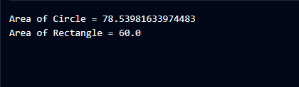
2)
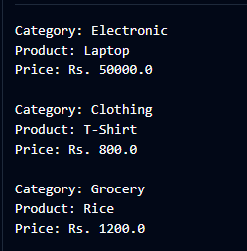
Conclusion
Thus, both programs demonstrate the concept of inheritance in Java using real-world examples. The Shape application shows how Circle and Rectangle inherit from the Shape class and calculate their respective areas. The E-Commerce Product System demonstrates how Electronic, Clothing, and Grocery inherit common properties from the Product class. These programs help in understanding code reusability, inheritance, and abstraction in Java.

